Supplementary information

Language-like efficiency and structure in house finch song

Mason Youngblood [1] [2]

# 1 Data

Recordings from 1975 were collected with a Nagra III reel-to-reel tape recorder and a Sennheiser 804 shotgun microphone and converted to digital files (32 bit, 96 kHz) by the Cornell Lab of Ornithology in 2013 (1). Recordings from 2012 (16 bit, 44.1 kHz) and 2019 (32 bit, 48 kHz) were collected with a Marantz PD661 solid-state recorder and a Sennheiser ME66 shotgun microphone. The recordings from 1975 were downsampled to 48 kHz prior to analysis (Luscinia processes both 44.1 kHz and 48 kHz files). In all three years special precautions were taken to avoid recording the same bird twice (1). Each site was visited only once. Within a site, only one individual was recorded within a 160 m radius until they stopped singing or flew away.

All songs were analyzed by (3) using Luscinia, a database and analysis program developed specifically for birdsong (<https://rflachlan.github.io/Luscinia/>). Songs were analyzed with a high-pass threshold of 2000 Hz, a maximum frequency of 9000 Hz and 5 dB of noise removal. 965 songs (26.2%) were excluded from the analysis due to high levels of noise. Continuous traces with more than 20 ms between them were classified as syllables (2).

Figure 1 shows an example of the first ten syllables of a house finch song recorded by (2) and analyzed in Luscinia, where the blue line is the mean frequency over time.

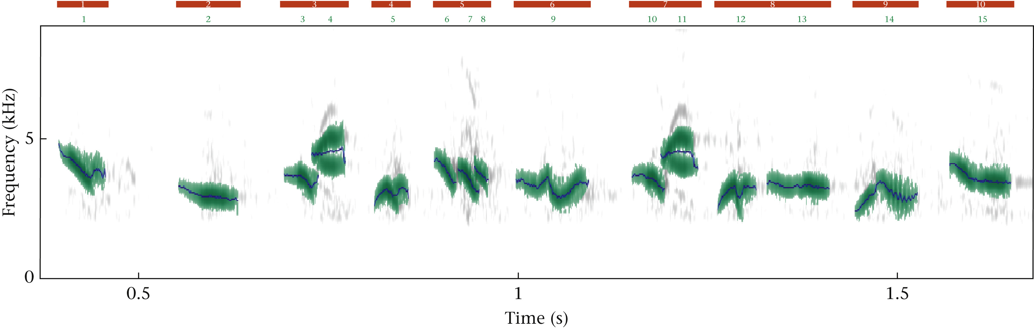

Figure S1: The first 10 syllables from a song recorded by (2) and analyzed in Luscinia. Each red bar corresponds to a syllable, and each green number corresponds to an element within that syllable. The blue traces represent mean frequency. In this song, syllable 3 and syllable 7 were classified as the same syllable type during dynamic time warping, and all other syllables are unique types. Reprinted from (3).

# 2 Clustering

The deep split parameter ($DS$) determines the granularity of clustering by controlling the value of two other parameters: the maximum core scatter ($MCS$), which controls the maximum within-group variation, and the minimum gap ($MG$), which controls the minimum between-group variation (4,5). $DS=\{0,1,2,3,4\}$ correspond to $MCS=\{0.64,0.73,0.82,0.91,0.95\}$, and $MG=\left(1−MCS\right)*0.75$. In their analyses of house finch song, (1) and (6) manually set $MCS=1$ and $MG=0.5$ while (3) used $DS=3$ (corresponding to $MCS=0.91$ and $MG=0.0675$), all of which led to a similar number of syllable types. I will follow (3) in using the simpler deep split parameter to control granularity in clustering, as this approach is recommended by the creators of dynamic tree cut (4) and has been widely used for a variety of applications (7,8) including vocal analysis (9).

# 3 Zipf’s Rank-Frequency Law

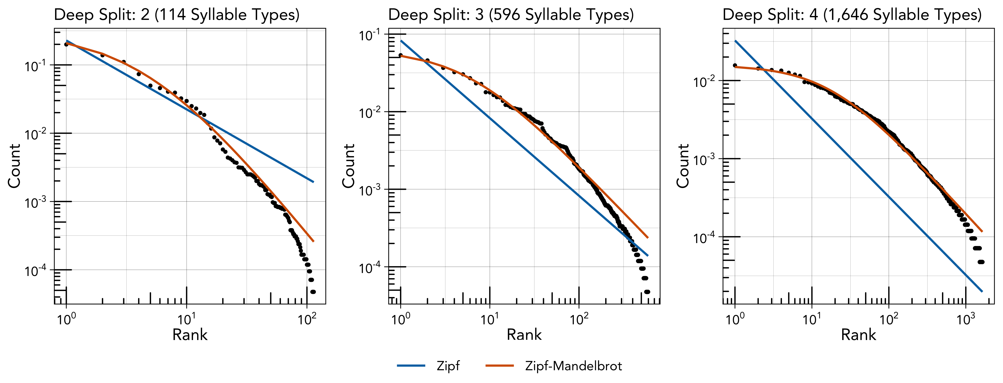

Figure S2: The relationship between rank (x-axis) and count (y-axis) at each level of deep split (left, center, and right). The blue and orange lines denote the expected distributions according to Zipf’s rank-frequency law (blue) and Mandelbrot’s extension of it (orange).

## 3.1 Priors and Diagnostics

Table S1: Prior specification for the Zipf and Zipf-Mandelbrot models fit across the three levels of granularity.

| **Parameter** | **Class** | **Prior** | **Lower Bound** |
| --- | --- | --- | --- |
| a | b | normal(0, 10) | 1 |
| b | b | normal(0, 10) | -1 |
| c | b | normal(0, 10) | 0 |
|  | sigma | student_t(3, 0, 2.5) | 0 |

Table S2: WAIC values from the Zipf and Zipf-Mandelbrot models fit across the three levels of granularity.

| **DS** | **Zipf** | **Zipf-Mandelbrot** |
| --- | --- | --- |
| 1 | -799 | -1,075 |
| 2 | -5,328 | -7,817 |
| 3 | -17,566 | -25,617 |

## 3.2 Deep Split: 2

Table S3: Estimates and diagnostics for the Zipf model.

| **Param.** | **Estimate** | **l-95% CI** | **u-95% CI** | **Rhat** | **Bulk_ESS** | **Tail_ESS** |
| --- | --- | --- | --- | --- | --- | --- |
| a | 1.01 | 1.00 | 1.03 | 1 | 5,510 | 3,580 |
| c | 0.23 | 0.22 | 0.24 | 1 | 7,223 | 6,440 |

Table S4: Estimates and diagnostics for the Zipf-Mandelbrot model.

| **Param.** | **Estimate** | **l-95% CI** | **u-95% CI** | **Rhat** | **Bulk_ESS** | **Tail_ESS** |
| --- | --- | --- | --- | --- | --- | --- |
| a | 2.20 | 2.03 | 2.39 | 1 | 2,129 | 2,702 |
| b | 4.66 | 4.00 | 5.41 | 1 | 2,132 | 2,653 |
| c | 9.43 | 5.22 | 16.68 | 1 | 2,102 | 2,515 |

## 3.3 Deep Split: 3

Table S5: Estimates and diagnostics for the Zipf model.

| **Param.** | **Estimate** | **l-95% CI** | **u-95% CI** | **Rhat** | **Bulk_ESS** | **Tail_ESS** |
| --- | --- | --- | --- | --- | --- | --- |
| a | 1.00 | 1.00 | 1.00 | 1 | 6,264 | 4,253 |
| c | 0.08 | 0.08 | 0.09 | 1 | 7,540 | 5,954 |

Table S6: Estimates and diagnostics for the Zipf-Mandelbrot model.

| **Param.** | **Estimate** | **l-95% CI** | **u-95% CI** | **Rhat** | **Bulk_ESS** | **Tail_ESS** |
| --- | --- | --- | --- | --- | --- | --- |
| a | 1.20 | 1.18 | 1.22 | 1 | 2,132 | 1,965 |
| b | 5.69 | 5.42 | 5.98 | 1 | 2,187 | 2,477 |
| c | 0.52 | 0.48 | 0.56 | 1 | 2,094 | 2,123 |

## 3.4 Deep Split: 4

Table S7: Estimates and diagnostics for the Zipf model.

| **Param.** | **Estimate** | **l-95% CI** | **u-95% CI** | **Rhat** | **Bulk_ESS** | **Tail_ESS** |
| --- | --- | --- | --- | --- | --- | --- |
| a | 1.00 | 1.00 | 1.00 | 1 | 6,266 | 4,117 |
| c | 0.03 | 0.03 | 0.03 | 1 | 8,434 | 7,188 |

Table S8: Estimates and diagnostics for the Zipf-Mandelbrot model.

| **Param.** | **Estimate** | **l-95% CI** | **u-95% CI** | **Rhat** | **Bulk_ESS** | **Tail_ESS** |
| --- | --- | --- | --- | --- | --- | --- |
| a | 1.08 | 1.07 | 1.09 | 1 | 2,079 | 2,879 |
| b | 17.29 | 16.79 | 17.79 | 1 | 2,076 | 3,021 |
| c | 0.34 | 0.32 | 0.36 | 1 | 2,032 | 2,774 |

## 3.5 Analysis by Year

Table S9: ΔWAIC comparing the fit of Zipf-Mandelbrot to Zipf's law separately to the data from each year at each level of deep split. Zipf-Mandelbrot provides a better fit in all conditions.

| **Year** | **DS: 2** | **DS: 3** | **DS: 4** |
| --- | --- | --- | --- |
| 1975 | -174 | -1,263 | -5,207 |
| 2012 | -156 | -1,958 | -5,518 |
| 2019 | -212 | -1,700 | -4,813 |

Table S10: The R² for the Zipf-Mandelbrot distribution fit separately to the data from each year at each level of deep split.

| **Year** | **DS: 2** | **DS: 3** | **DS: 4** |
| --- | --- | --- | --- |
| 1975 | 0.993 | 0.985 | 0.994 |
| 2012 | 0.987 | 0.991 | 0.986 |
| 2019 | 0.991 | 0.993 | 0.996 |

# 4 Zipf’s Law of Abbreviation

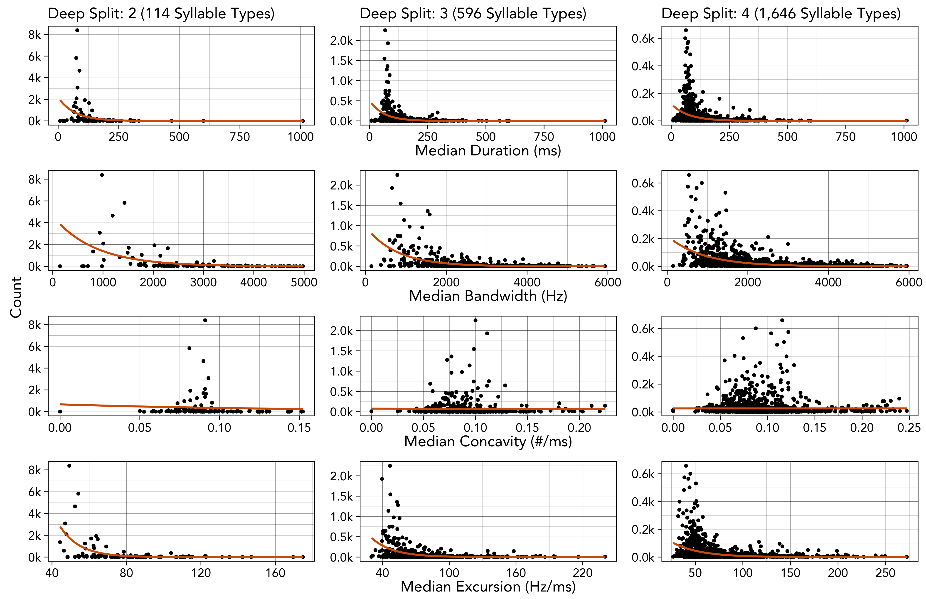

Figure S3: The relationship between four measures of production cost (x-axis) and count (y-axis) for each level of deep split (left, center, right). Each point shows the median value for a syllable type, so the orange best fit lines are from a simple Poisson model (count ~ cost) rather than the full log-normal model.

## 4.1 Priors and Diagnostics

Table S11: Prior specification for all four models of Zipf's law of abbreviation.

| **Class** | **Prior** | **Lower Bound** |
| --- | --- | --- |
| b | normal(0, 0.5) |  |
| Intercept | normal(0, 4) | 0 |
| sd | normal(0, 0.5) | 0 |
| sigma | normal(0, 0.5) | 0 |

Table S12: The model diagnostics for each model of Zipf's law of abbreviation.

| **Outcome** | **DS** | **Predictor** | **Rhat** | **Bulk ESS** | **Tail ESS** |
| --- | --- | --- | --- | --- | --- |
| Duration | 2 | Intercept | 1 | 712 | 913 |
| Count | 1 | 794 | 1,064 |
| 3 | Intercept | 1 | 451 | 915 |
| Count | 1 | 566 | 1,069 |
| 4 | Intercept | 1 | 268 | 580 |
| Count | 1 | 302 | 597 |
| Bandwidth | 2 | Intercept | 1 | 835 | 1,801 |
| Count | 1 | 1,047 | 2,088 |
| 3 | Intercept | 1 | 184 | 448 |
| Count | 1 | 230 | 586 |
| 4 | Intercept | 1 | 170 | 406 |
| Count | 1 | 230 | 525 |
| Concavity | 2 | Intercept | 1 | 1,059 | 2,059 |
| Count | 1 | 1,354 | 2,695 |
| 3 | Intercept | 1 | 1,307 | 2,561 |
| Count | 1 | 1,546 | 3,209 |
| 4 | Intercept | 1 | 723 | 1,469 |
| Count | 1 | 775 | 1,620 |
| Excursion | 2 | Intercept | 1 | 1,301 | 2,456 |
| Count | 1 | 1,508 | 2,661 |
| 3 | Intercept | 1 | 735 | 1,398 |
| Count | 1 | 855 | 1,592 |
| 4 | Intercept | 1 | 403 | 771 |
| Count | 1 | 479 | 956 |

## 4.2 Analysis by Year

Table S13: The estimated effect of count on each measure of production cost, in frequentist models that include year as a varying intercept, using the syllable classifications from each level of deep split. 95% confidence intervals that do not overlap with 0 are marked with an asterisk. The results are qualitatively identical to the main analysis.

| **Model** | **DS** | **Est.** | **2.5%** | **97.5%** |  |
| --- | --- | --- | --- | --- | --- |
| duration ~ count | 2 | -0.38 | -0.66 | -0.10 | * |
| 3 | -0.47 | -0.59 | -0.35 | * |
| 4 | -0.42 | -0.48 | -0.36 | * |
| bandwidth ~ count | 2 | -0.56 | -0.77 | -0.35 | * |
| 3 | -0.69 | -0.80 | -0.58 | * |
| 4 | -0.64 | -0.70 | -0.58 | * |
| concavity ~ count | 2 | -0.02 | -0.21 | 0.17 |  |
| 3 | -0.06 | -0.15 | 0.03 |  |
| 4 | -0.07 | -0.13 | -0.02 | * |
| excursion ~ count | 2 | -0.27 | -0.42 | -0.12 | * |
| 3 | -0.34 | -0.41 | -0.26 | * |
| 4 | -0.32 | -0.36 | -0.28 | * |

# 5 Menzerath’s Law

## 5.1 Priors and Diagnostics

Table S14: Prior specification for the model of Menzerath's law.

| **Class** | **Prior** | **Lower Bound** |
| --- | --- | --- |
| b | normal(0, 0.1) |  |
| Intercept | normal(0, 3) | 0 |
| sd | normal(0, 0.5) | 0 |
| sigma | normal(0, 0.5) | 0 |

Table S15: Estimates and diagnostics for the model of Menzerath's law applied to the real data.

| **Param.** | **Estimate** | **l-95% CI** | **u-95% CI** | **Rhat** | **Bulk_ESS** | **Tail_ESS** |
| --- | --- | --- | --- | --- | --- | --- |
| Intercept | 4.48 | 4.47 | 4.49 | 1 | 6,740 | 7,103 |
| Song Length | -0.05 | -0.07 | -0.04 | 1 | 4,794 | 6,044 |

Table S16: The R-hat values from the two null models applied to each of the 10 simulated datasets.

|  | **Simple Null Model** | | **Production Null Model** | |
| --- | --- | --- | --- | --- |
| **Dataset** | **Intercept** | **Song Length** | **Intercept** | **Song Length** |
| 1 | 0.9998875 | 0.9996983 | 0.9997456 | 1.000656 |
| 2 | 0.9997542 | 0.9997727 | 0.9999726 | 1.000328 |
| 3 | 1.0000627 | 0.9997787 | 0.9998281 | 1.001598 |
| 4 | 0.9997391 | 0.9997015 | 1.0005752 | 1.000895 |
| 5 | 0.9999400 | 1.0004971 | 0.9997567 | 1.000817 |
| 6 | 0.9999405 | 0.9998756 | 0.9997009 | 1.000332 |
| 7 | 0.9999780 | 0.9998101 | 0.9997015 | 1.001533 |
| 8 | 1.0005872 | 0.9998251 | 0.9998900 | 1.000225 |
| 9 | 0.9999938 | 0.9997752 | 0.9998704 | 1.001099 |
| 10 | 0.9997444 | 0.9998224 | 1.0001865 | 1.002680 |

## 5.2 Analysis by Year

Table S17: Estimates for a frequentist version of the model of Menzerath's law applied to the real data, with year added as a varying intercept. The results are qualitatively identical to the main analysis.

| **Param.** | **Estimate** | **2.5%** | **97.5%** |
| --- | --- | --- | --- |
| Intercept | 4.500 | 4.40 | 4.600 |
| Song Length | -0.047 | -0.06 | -0.033 |

# 6 Small-Worldness Index

## 6.1 Analysis by Year

Table S18: The small-worldness index computed separately from the data from each year at each level of deep split.

| **Year** | **DS: 2** | **DS: 3** | **DS: 4** |
| --- | --- | --- | --- |
| 1975 | 1.88 | 5.58 | 10.45 |
| 2012 | 1.76 | 5.71 | 13.34 |
| 2019 | 2.09 | 6.95 | 14.30 |

# 7 Mutual Information

Table S19: The WAIC and R-Squared value for each model at each level of deep split.

| **DS** | **Model** | **WAIC** | **R-Sq** |
| --- | --- | --- | --- |
| 2 | Exponential | -829 | 0.951 |
| Power-Law | -766 | 0.910 |
| Composite | -840 | 0.952 |
| 3 | Exponential | -617 | 0.982 |
| Power-Law | -487 | 0.927 |
| Composite | -668 | 0.986 |
| 4 | Exponential | -599 | 0.990 |
| Power-Law | -432 | 0.926 |
| Composite | -688 | 0.993 |

## 7.1 Priors and Diagnostics

Table S20: Prior specification for all three models of mutual information decay.

| **Parameter** | **Prior** | **Lower Bound** |
| --- | --- | --- |
| a | normal(0, 1) | 0 |
| b | normal(0, 1) | 0 |
| c | normal(0, 1) | 0 |
| d | normal(0, 1) | 0 |

Table S21: The WAIC values for each model, at each level of deep split, for increasing maximum distances between syllables.

|  | **2** | | | **3** | | | **4** | | |
| --- | --- | --- | --- | --- | --- | --- | --- | --- | --- |
|  | **Exp** | **PL** | **Comp** | **Exp** | **PL** | **Comp** | **Exp** | **PL** | **Comp** |
| 100 | -829 | -765 | -841 | -617 | -486 | -668 | -598 | -432 | -688 |
| 200 | -1,557 | -1,513 | -1,560 | -1,232 | -1,068 | -1,281 | -1,201 | -967 | -1,267 |
| 300 | -2,101 | -2,086 | -2,114 | -1,635 | -1,555 | -1,695 | -1,626 | -1,468 | -1,686 |
| 400 | -2,683 | -2,676 | -2,712 | -2,008 | -1,977 | -2,131 | -2,082 | -1,950 | -2,142 |
| 500 | -2,984 | -2,988 | -3,073 | -2,078 | -2,093 | -2,276 | -2,260 | -2,217 | -2,387 |
| 600 | -3,114 | -3,176 | -3,248 | -2,264 | -2,299 | -2,527 | -2,454 | -2,449 | -2,639 |
| 700 | -3,291 | -3,430 | -3,471 | -2,493 | -2,539 | -2,808 | -2,650 | -2,669 | -2,901 |
| 800 | -3,620 | -3,734 | -3,766 | -2,479 | -2,598 | -2,798 | -2,209 | -2,240 | -2,485 |
| 900 | -3,615 | -3,785 | -3,801 | -2,108 | -2,379 | -2,467 | -1,568 | -1,804 | -1,886 |
| 1000 | -3,712 | -3,931 | -3,942 | -1,958 | -2,350 | -2,408 | -1,235 | -1,608 | -1,654 |
| 1200 | -3,175 | -3,244 | -3,246 | -1,483 | -1,711 | -1,731 | -823 | -1,084 | -1,104 |

## 7.2 Deep Split: 2

Table S22: Estimates and diagnostics for exponential model.

| **Param.** | **Estimate** | **l-95% CI** | **u-95% CI** | **Rhat** | **Bulk_ESS** | **Tail_ESS** |
| --- | --- | --- | --- | --- | --- | --- |
| a | 0.17 | 0.16 | 0.19 | 1 | 4,336 | 4,595 |
| b | 0.39 | 0.35 | 0.44 | 1 | 4,511 | 4,996 |

Table S23: Estimates and diagnostics for power-law model.

| **Param.** | **Estimate** | **l-95% CI** | **u-95% CI** | **Rhat** | **Bulk_ESS** | **Tail_ESS** |
| --- | --- | --- | --- | --- | --- | --- |
| c | 0.13 | 0.12 | 0.14 | 1 | 6,738 | 7,059 |
| d | 1.08 | 1.01 | 1.15 | 1 | 6,437 | 6,285 |

Table S24: Estimates and diagnostics for composite model.

| **Param.** | **Estimate** | **l-95% CI** | **u-95% CI** | **Rhat** | **Bulk_ESS** | **Tail_ESS** |
| --- | --- | --- | --- | --- | --- | --- |
| a | 0.16 | 0.12 | 0.18 | 1 | 3,354 | 3,685 |
| b | 0.43 | 0.38 | 0.48 | 1 | 4,592 | 4,387 |
| c | 0.02 | 0.00 | 0.04 | 1 | 3,021 | 2,579 |
| d | 0.66 | 0.29 | 0.96 | 1 | 3,237 | 2,798 |

## 7.3 Deep Split: 3

Table S25: Estimates and diagnostics for exponential model.

| **Param.** | **Estimate** | **l-95% CI** | **u-95% CI** | **Rhat** | **Bulk_ESS** | **Tail_ESS** |
| --- | --- | --- | --- | --- | --- | --- |
| a | 0.60 | 0.57 | 0.64 | 1 | 4,478 | 5,210 |
| b | 0.27 | 0.26 | 0.29 | 1 | 4,453 | 5,343 |

Table S26: Estimates and diagnostics for power-law model.

| **Param.** | **Estimate** | **l-95% CI** | **u-95% CI** | **Rhat** | **Bulk_ESS** | **Tail_ESS** |
| --- | --- | --- | --- | --- | --- | --- |
| c | 0.52 | 0.49 | 0.56 | 1 | 6,895 | 5,998 |
| d | 0.95 | 0.90 | 1.00 | 1 | 7,133 | 7,055 |

Table S27: Estimates and diagnostics for composite model.

| **Param.** | **Estimate** | **l-95% CI** | **u-95% CI** | **Rhat** | **Bulk_ESS** | **Tail_ESS** |
| --- | --- | --- | --- | --- | --- | --- |
| a | 0.53 | 0.47 | 0.59 | 1 | 2,820 | 3,907 |
| b | 0.30 | 0.28 | 0.32 | 1 | 4,896 | 4,646 |
| c | 0.08 | 0.04 | 0.13 | 1 | 2,882 | 2,864 |
| d | 0.61 | 0.42 | 0.77 | 1 | 2,978 | 3,096 |

## 7.4 Deep Split: 4

Table S28: Estimates and diagnostics for exponential model.

| **Param.** | **Estimate** | **l-95% CI** | **u-95% CI** | **Rhat** | **Bulk_ESS** | **Tail_ESS** |
| --- | --- | --- | --- | --- | --- | --- |
| a | 0.74 | 0.71 | 0.77 | 1 | 3,787 | 4,572 |
| b | 0.24 | 0.23 | 0.25 | 1 | 4,287 | 5,362 |

Table S29: Estimates and diagnostics for power-law model.

| **Param.** | **Estimate** | **l-95% CI** | **u-95% CI** | **Rhat** | **Bulk_ESS** | **Tail_ESS** |
| --- | --- | --- | --- | --- | --- | --- |
| c | 0.69 | 0.64 | 0.73 | 1 | 6,835 | 6,785 |
| d | 0.92 | 0.87 | 0.97 | 1 | 6,638 | 6,848 |

Table S30: Estimates and diagnostics for composite model.

| **Param.** | **Estimate** | **l-95% CI** | **u-95% CI** | **Rhat** | **Bulk_ESS** | **Tail_ESS** |
| --- | --- | --- | --- | --- | --- | --- |
| a | 0.65 | 0.59 | 0.71 | 1 | 2,387 | 2,851 |
| b | 0.26 | 0.25 | 0.27 | 1 | 4,566 | 4,959 |
| c | 0.10 | 0.05 | 0.15 | 1 | 2,433 | 2,760 |
| d | 0.61 | 0.45 | 0.74 | 1 | 2,360 | 2,726 |

## 7.5 Analysis by Year

Table S31: The WAIC values for the exponential, power-law, and composite models applied to the mutual information calculated separately from the data from each year at each level of deep split. The composite model outcompetes both alternatives in all conditions.

| **DS** | **Year** | **Exponential** | **Power-Law** | **Composite** |
| --- | --- | --- | --- | --- |
| 2 | 1975 | -653 | -607 | -656 |
| 2012 | -547 | -421 | -564 |
| 2019 | -521 | -427 | -571 |
| 3 | 1975 | -724 | -685 | -725 |
| 2012 | -598 | -446 | -607 |
| 2019 | -588 | -427 | -640 |
| 4 | 1975 | -687 | -671 | -723 |
| 2012 | -518 | -396 | -572 |
| 2019 | -511 | -370 | -587 |

# References

1. Ju C, Geller FC, Mundinger PC, Lahti DC. [Four decades of cultural evolution in house finch songs](https://doi.org/10.1093/auk/uky012). The Auk: Ornithological Advances. 2019;136:1–18.

2. Mundinger PC. Song dialects and colonization in the house finch, Carpodacus mexicanus, on the east coast. The Condor [Internet]. 1975;77(4):407–22. Available from: <https://doi.org/10.2307/1366088>

3. Youngblood M, Lahti D. [Content bias in the cultural evolution of house finch song](https://doi.org/10.1016/j.anbehav.2021.12.012). Animal Behaviour. 2022;185:37–48.

4. Langfelder P, Zhang B, Horvath S. Defining clusters from a hierarchical cluster tree: the Dynamic Tree Cut package for R. Bioinformatics [Internet]. 2008 Mar 1 [cited 2023 Jun 2];24(5):719–20. Available from: <https://academic.oup.com/bioinformatics/article/24/5/719/200751>

5. Ju C. FinchCatcher [Internet]. Department of Biology, Queens College; 2016. Available from: <http://finchcatcher.net>

6. Roginek EW. Spatial variation of house finch (Haemorhous mexicanus) song along the American Southwest coast. Queens College; 2018.

7. Liu S, Lu Y, Geng D. Molecular Subgroup Classification in Alzheimer’s Disease by Transcriptomic Profiles. J Mol Neurosci [Internet]. 2022 Apr 1 [cited 2023 Jun 2];72(4):866–79. Available from: <https://doi.org/10.1007/s12031-021-01957-w>

8. Zhao H, Zhang S, Shao S, Fang H. Identification of a Prognostic 3-Gene Risk Prediction Model for Thyroid Cancer. Frontiers in Endocrinology [Internet]. 2020 [cited 2023 Jun 2];11. Available from: <https://www.frontiersin.org/articles/10.3389/fendo.2020.00510>

9. Burkett ZD, Day NF, Peñagarikano O, Geschwind DH, White SA. VoICE: A semi-automated pipeline for standardizing vocal analysis across models. Sci Rep [Internet]. 2015 May 28 [cited 2023 Jun 2];5(1):10237. Available from: <https://www.nature.com/articles/srep10237>

1. Minds and Traditions Research Group, Max Planck Institute for Geoanthropology, [masonyoungblood@gmail.com](mailto:masonyoungblood@gmail.com)
2. Institute for Advanced Computational Science, Stony Brook University